To demonstrate the functionality of the product we will walk you through the tests we have completed.

Test 1: Multiple players

1. First we will connect to the game server
2. After Connecting the player will set how players will be playing the game for now set the player count to 2
3. Click “Start Game” and see how many player tiles are presented on the screen
4. If there are the requested then repeat the test with 3 and 4 four players to confirm passability
5. If all player counts work then test is confirmed a pass

Results of Test 1:

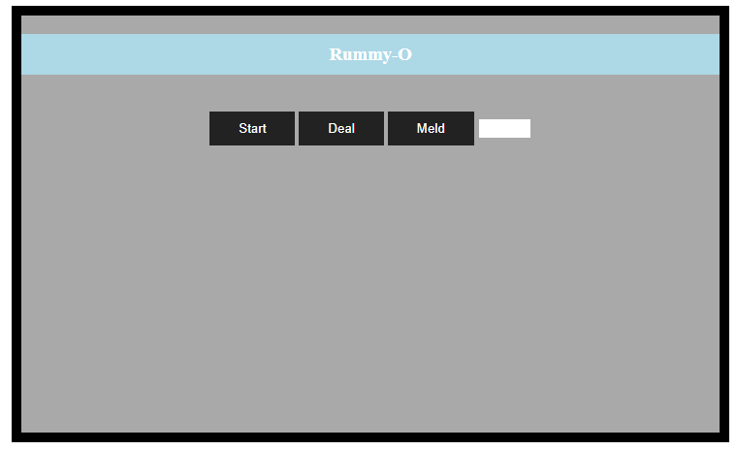

Figure 1.1: Connection to the game

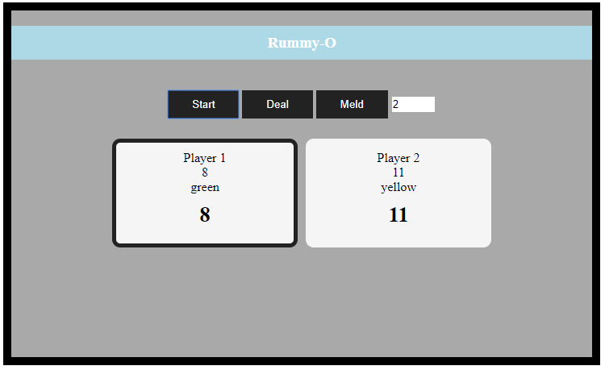

Figure 1.2: Two players in the game

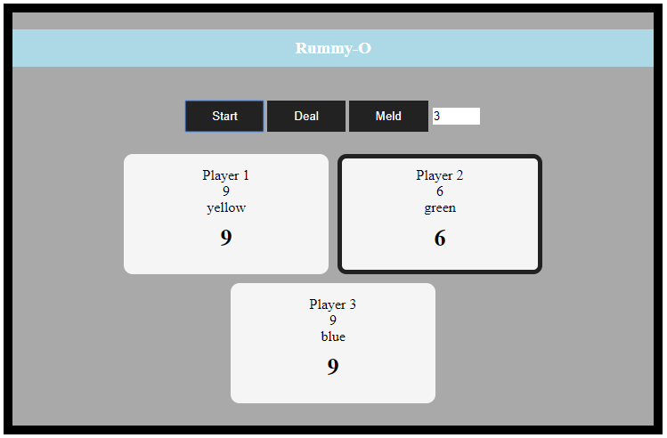

Figure 1.3: Three players in the game

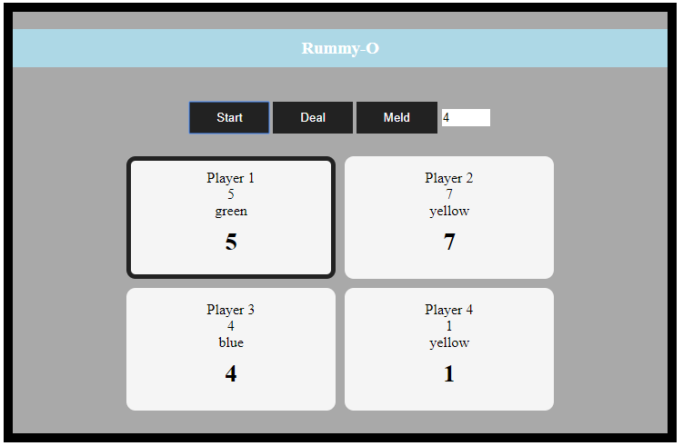

Figure 1.4: 4 Players in game

Based on Figures 1.2-1.4 above we see that the ability to play with multiple people is possible and therefore the product passes the first test.

Test 2: Deal Players Hands

PreConditions:

* The player has connected
* The number of players has been selected
* The game has been started by the “Start” Button

Procedure:

1. The player hits the “Deal” Button
2. Check to see if hands have been created for the players

The test is passed if the players all receive tile in their hands

Results of Test 2:

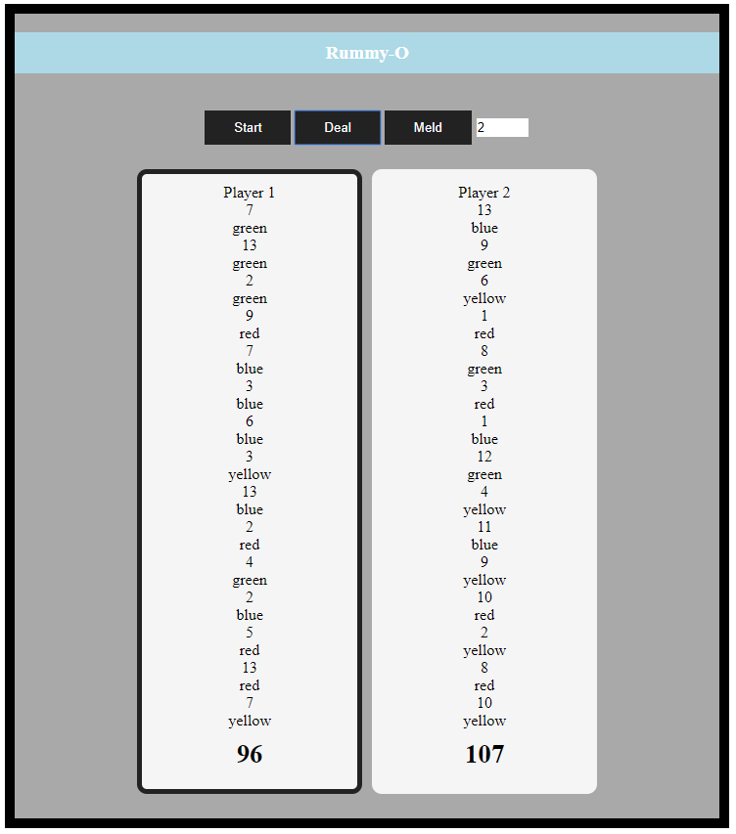

Figure 2.1: The hands have been dealt

The test is passed as each player has been dealt hands

Test 3: Selecting first player

PreConditions:

* The player has connected
* The number of players has been selected

Procedure:

1. The player hits the “Start” Button
2. Since the function that selects the first player is called automatically we will only need the check for the pass condition

The test is passed if 1(one) of the players has been outlined in black

Results of test 3:

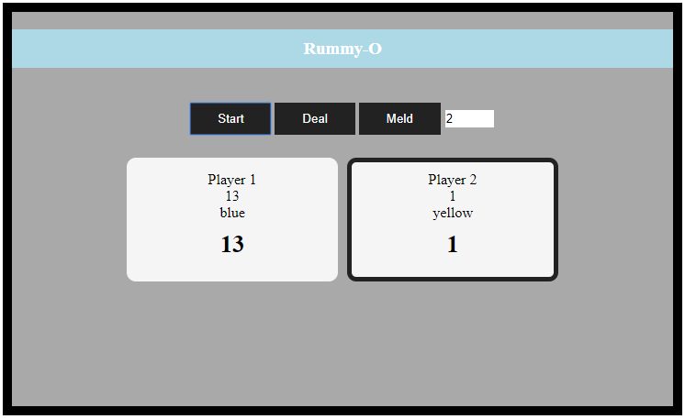

Figure 3.1: Player 2 goes first

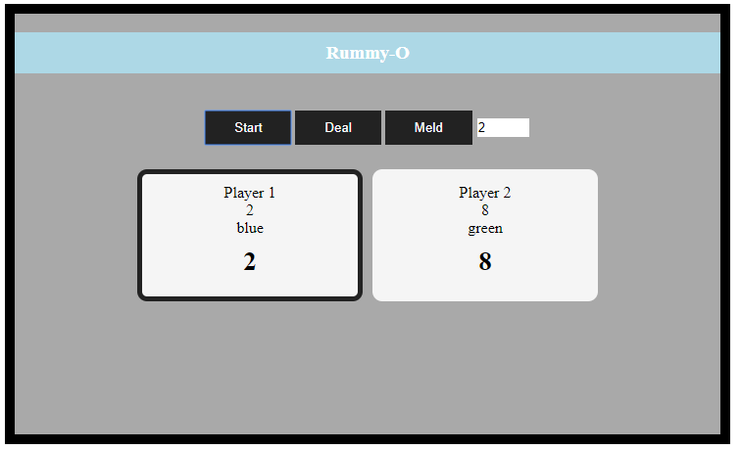

Figure 3.2: Player 1 is outlined

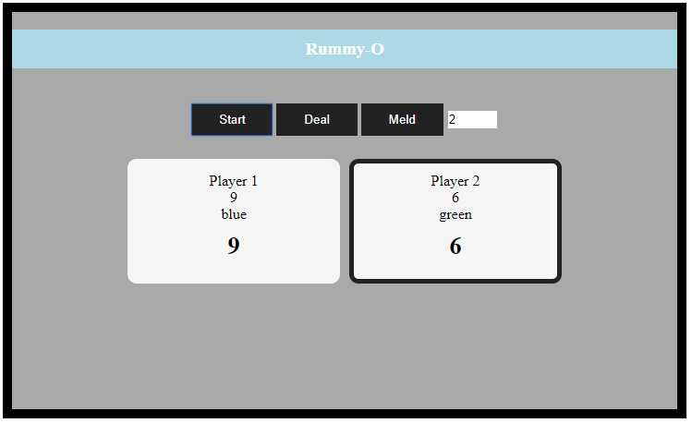

Figure 3.3: Player 2 is outlined

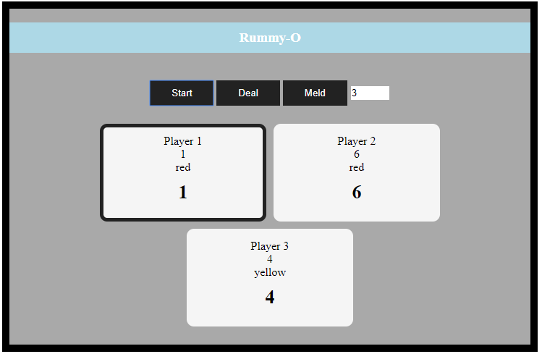

Figure 3.4: A 3 player game works too

Therefore looking at the test results above in figures 3.1-3.4 we can see that the first play selection system works as requested and the test is passed